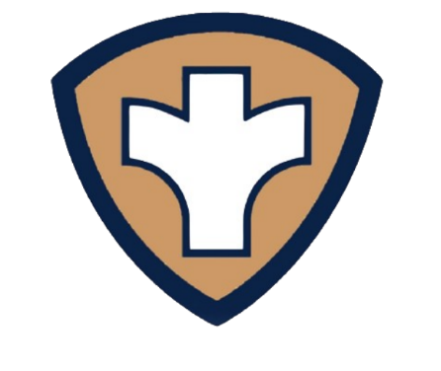
freeCLINIC
of

Wayne County

4th Tuesday - Corydon
Every
Month!

Your health is our priority!

No Appointment needed Free Labratory Services* Free Medications*
Free Childhood Immunizations Free Covid Vaccines
No Insurance Needed
This clinic will help serve those who are without insurance, underinsured, as well as those with high premiums, co-pays and deductibles.
Prevent. Promote. Protect.
Donations accepted but not expected.
*Medication cost and lab fees may apply in extenuating circumstances.

Amish Community Center
Follow GPS to 3010 Edison Road
Seymour, IA 52590

Wayne County Public Health Office
105 N. Lafayette
Corydon, IA 50060
5:30pm - 7:30pm
You must sign up by 6:30 pm
All are welcome !!

Wayne County
Public Health
TEL. 641-872-1167
www.waynecountypublichealth.org

